Cardinal Health Inc - Change Request

Version Control:
Version | Date | Authors | Change Description
1.0 | 23-Feb-2023 | Genpact | CAF-2374– Need to skip AP approval if invoice already approved in BP by the same user.
1.1 | 05-Apr-2023 | Genpact | CAF-2374– Need to skip AP approval if invoice already approved in BP by the same user.
1.2 | 10-May-2023 | Genpact | CAF-2374– Need to skip AP approval if invoice already approved in BP by the same user.
1.3 | 01-March-2024 | Genpact | CAF-2374– Need to skip AP approval if invoice already approved in BP by the same user.

Approved by:

Name | Project Role | Organization | Version | Sign off | Signoff Date
Amanda Singh | Business Lead (PTP) | Cardinal Health | 1.3 | Required
Michelle Besse | IT Lead | Cardinal Health | 1.3 | Required
Deepak Soni | Business SME | Genpact | 1.3 | Required
Amy McManus |  | Cardinal Health | 1.3 | Required
Robinette Gerald |  | Cardinal Health | 1.3 | Required

Instructions for Use
Please fill out this Cora change request template to the best of your knowledge. Why? Because if you do (1) We will have a more reliable change request/enhancement process, (2) Product Managers will have more information from which to make scoping decisions, and (3) Development team will have a clearer idea of what needs to be implemented.

SOW XX
CR Number | CAF-2374
Raised by | Cardinal Health Ops Team
Raised on Date | Jan-2022
Change Request High level description | Need to skip AP approval if invoice already approved in BP:  Existing setup:  Cardinal AP Flow – Currently, the Invoice is being approved by same Approver user in Buyer Portal (Approved by Supervisor) and Cora AP (When invoice sends for CAH Supervisory Approval).  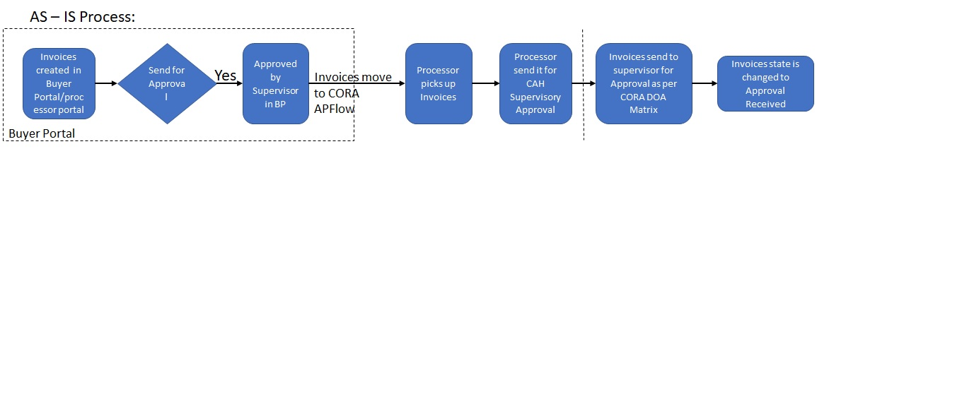  Proposed Solution:  Business wants to skip AP approval in CORA AP, if invoice already approved in Buyer Portal with same BPO user.  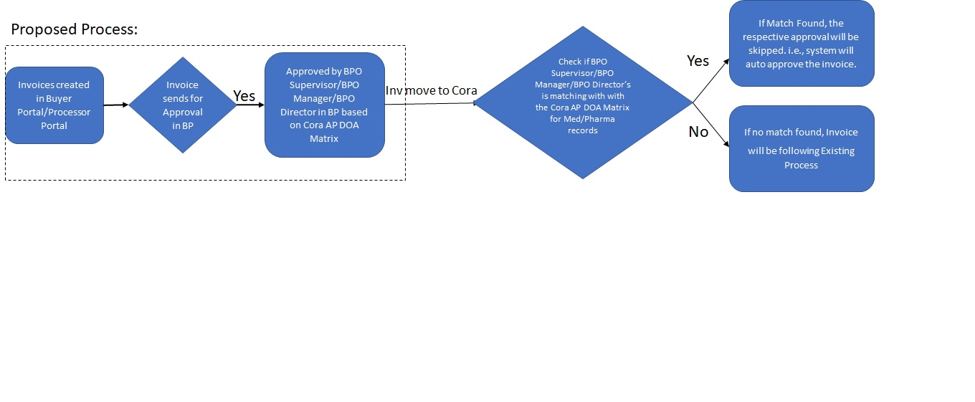  Note: This will be system Automatic check.
Description of Change Request | Description of the Changes in Cora APFlow:  - As per the above-mentioned description, need to skip the AP Approval process in CORA, if invoice already approved by the same BPO user in buyer portal.  - Below are the steps for skipping the approval process in CORA.  Case:  - Invoices will be created in Buyer Portal/CoraAP Flow.  - For Certain Work Type and Document Type combination it will be routed to Buyer Portal for BPO Supervisor/BPO Manager/BPO Director approval.  - If Approved in Buyer portal, we need to match the Buyer Portal BPO Approver User with CoraAP DOA Matrix records based on Approval limit.  - If the BPO Supervisor/BPO Manager/BPO Director who approved the invoice matches with the Cora AP Flow DOA Matrix Criteria. In this case, the respective user approval will be skipped, that is system will perform the auto approval and move the invoice to next stage.  - Otherwise, it will follow the existing process.  Limitations:  - This change is only applicable for Direct Non-PO Invoices.  - Above case should be applicable only if Approver who approved the invoice in Buyer Portal matches with one of the DOA matrix users for Medical and Pharma invoices only in Cora.  - This change will be only applicable for Medical/Pharma DNPO Invoices.  - Any change out this BRD scope will be considered as separate CR.
Reason for Change Request | Business wants to skip CORA AP approval process if invoice already approved in Buyer Portal. This will lead to reduce the time and effort for the processor.
Areas Impacted | Cora APFlow
Priority | High
Business Impact | What is the technical severity of this issue?  Severity 1 – Existing feature is unusable, and no reasonable workaround exists  Severity 2 – Existing feature is unusable, but a reasonable workaround exists  Severity 3 – Existing feature is usable as documented but does not perform additional needed functions  Severity 4 – Improvement to existing and usable feature  Severity 5 – Cosmetic  What would be the impact the customer’s business if this functionality were not enhanced?  Business processes cannot move forward without this enhancement  Business processes are severely impacted by this enhancement, but continue to operate – albeit in a less than efficient manner  Business processes are moderately impacted by this enhancement. Processes move forward at an expected but not exceptional rate  Business processes are slightly impacted by this enhancement. Processes move forward at best possible rate but could be further improved with this enhancement.  No impact to existing business processes. The enhancement request may represent a possible future direction or enhancement to existing products but without a definite business justification.  Other -- please specify: System is under development, and which may not impact business.
Other Comments / Expectations | - There is No Audit trail for this change because it is automatic skip to the next level approval.  - This is also dependant on ENHUAT Environment as to check the flow with Buyer portal.
Timeframe Expectations | In what time frame is this enhancement needed?  "There is an immediate need for this enhancement"  "This enhancement is needed in the next 3-6 months"  "This enhancement is needed in the next 6-12 months"  "This enhancement is needed in the next 12-24 months"  "This enhancement is needed in the next 12-24 months "  "There is no specific timeframe needed for this enhancement "
Current Implementation / Workaround | No Current implementation/workaround.
Project Plan and Timelines | - Post BRD Approval (Due to other CR’s Planned or in progress), we will start the Feasibility check with help of POC.  - On Successful POC, we will share the project timelines for Approval.

For Support Use Only.
Customer
Customer Contact
Support Representative
Jira Support Issue ID
Additional Internal Information

